Sculpture - Syllabus 2022-2023

(Pre-requisite: Visual Arts Comprehensive)

I. Teacher Information

Teacher name: Ms. Ensmann | Room: 1159
Tutorial Days: Tuesday 3:45-5:00pm | Google Classroom Code: bjpxsxw
Teacher Email: lana.ensmann@atlanta.k12.ga.us | Zoom information: 470 231 9125 pwd: pencil

Teacher name: Ms. Niles | Room: 1167
Tutorial Days: Tuesday 3:45-5:00pm | Google Classroom Code 4B Sculpture: vjuo5yc
Teacher Email: shalea.niles@atlanta.k12.ga.us

II. Course Description and Objectives

Introduces the design and production of relief sculpture and sculpture-in-the-round. Emphasizes the historical origins and functions of sculpture in Western and non-Western cultures. Includes additive, subtractive, and modeling methods. Explores traditional and nontraditional materials for sculpted works and the work of both historical and contemporary sculptural artists.

III. Materials and Supplies

Students can access the course materials and grades via Infinite campus and Google Classroom. Students should check Google Classroom regularly, as course changes will always be announced and recorded on the course site. Students are required to come to class prepared, which includes having their sketchbook, artwork/project, pencils, etc. Students may be asked to bring certain objects to aid in studio projects. The Maynard Art Department will provide other materials.

IV. Primary Text(s)
n/a

V. IB - Middle Years Programme

This course is part of the International Baccalaureate Middle Years Programme at Maynard Jackson High School which aims to help IBMYP learners to become principled, open-minded, caring, balanced, reflective, and knowledgeable inquirers, thinkers, communicators, and risk-takers. The learning experiences will allow students to gain analytical skills, promote informed decision-making, engage in teamwork and collaboration, frame their own inquiries, pursue personal aspirations, set challenging goals, and have the persistence to achieve them. Students will work towards a deepening of their conceptual understanding as they approach concepts from a range of perspectives. As concepts are studied throughout the year, the following global contexts will be in constant consideration: identities and relationships, orientation in time and space, fairness and development, globalization and sustainability, scientific and technical innovation, and personal and cultural expression. IB MYP Assessments aim to support and encourage student learning by providing feedback and promoting deep understanding of subject content by supporting students in their inquiry in real-world contexts. Specific assessment criteria with subject objectives will be provided. Timelines and descriptions of tasks will be provided. Students will be assessed on a 0-7 IB scale in order to receive an IB grade at the end of the course. The IB grade will not affect students’ transcript grades and it is for IB reporting purposes only.

A year-long IB MYP Personal Project accompanied by a journal is to be produced at the end of the 10th grade year. The Personal Project enables students to engage in practical exploration through a cycle of inquiry, action, and reflection. Over the course of their 10th grade year, students will receive a grade for their Personal Project each semester in all four of their core content classes ( Science, Math, English Language Arts, and Social Studies). The final project grade will count as a summative assessment for the second semester in all four courses. For more information about the Middle Years Programme Personal Project, please visit maynardjacksonib.weebly.com

VI. Course Outline/Curriculum Overview
Unit 1: Intro to sculpture process.
Unit 2: Additive Techniques.
Unit 3: Subtractive Techniques.
Unit 4: Kinetic Sculpture.
Unit 5: Assemblage Sculpture.
Unit 6: Site specific, Environmental

VII. Technology Expectations for Learning

- From district Expectations for Technology:
There may be times when the teacher will ask you to utilize your own technology during a class. This technology can include a smartphone, laptop, or tablet. When personal technology is not required by the teacher, the electronic device should be OFF and AWAY.

VIII. Grading Policy

Infinite Campus Categories | Weight | Sample Assignments
Formative Pre-Assessment | 0% | Pre-Test/Diagnostic Test
Assessment During Learning | 25% | Performance-based Assessments/Quizzes/Mid-unit
Group/Independent Practice (In Class) | 40% | Classwork/Projects/Labs/Group work/Read 180/ Math 180/APEX
Homework | 5% | Additional Practice (Khan Academy, Desmos, USA Test Prep, Geogebra, etc.)
Summative Assessment | 30% | MYP Assessments/Culminating Projects/Unit Tests/Final Exam

Grading Scale A: 90-100 B: 80-89 C: 70-79 F: 0-69

Grading Systems-Grading Expectations [See Board Policy IHA-R (1)]

https://go.boarddocs.com/ga/aps/Board.nsf/goto?open&id=9DGK564F8144#

IX. Assessment Calendar

Unit/Benchmark Assessments - TBD
Final Exam (December/May) - TBD
GA Milestone - TBD

X. Classroom Expectations

- Jaguar CODE - All classroom rules and expectations must be in the Jackson CODE format.
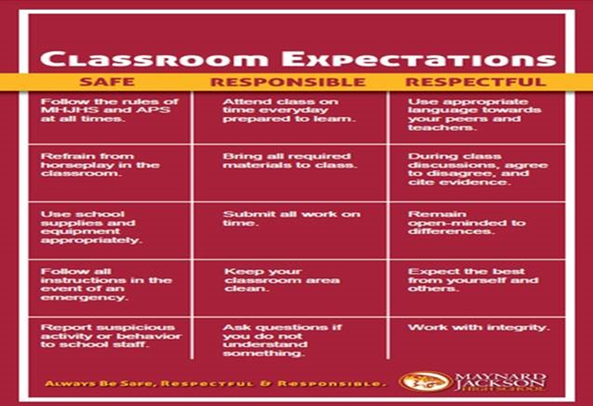

Incompletes/Make-Up

a. Students who have not demonstrated mastery of standards due to documented medical absences or other reasons approved by the principal may receive a temporary grade of “Incomplete” (I) with a written performance plan approved by the principal.

b. Student mastery must be reassessed and incompletes changed to an evaluation/grade within 4.5 weeks. The principal shall authorize all grade changes. (See Section 6. Grade Changes.)

c. If an incomplete is not changed during this time period, schools will update all such letter grades to the grade otherwise reflected in the grade book. The Data + Information Group will provide a report for schools of all outstanding “Incompletes”.

Deficiency Notices and Progress Reports
The student will periodically receive from the teacher GRADE PROGRESS reports and DEFICIENCY NOTICES. You should review with your parent(s) or guardian(s) AND they must sign and return both the GRADE PROGRESS REPORT and DEFICIENCY NOTICE on or before the assigned due date.

Academic Integrity
The Atlanta Board of Education recognizes that academic integrity is the foundation of academic excellence and student success. It is the responsibility of every student and employee to exhibit honesty, trust, fairness, respect, and responsibility in academic work at all times to support a positive learning environment in the school. Violations of board policy JFA Academic Integrity shall be handled as violations of the student code of conduct and addressed via the progressive discipline guidelines in the Student Handbook.

Cheating and Plagiarism Policy: The Maynard Jackson High School Honor Code is in effect at all times. Cheating will not be tolerated! Cheating is defined as giving or receiving information in any form that is related to a gradable experience including the use of sources of information other than those specifically approved by the teacher either during or outside of class. Students are required to sign honor pledges as applicable for major tests, projects, and/or papers.

Examples of cheating include, but are not limited to:
- Plagiarism – using words or ideas from a published source without proper documentation; using the work of another student (e.g. copying another student’s homework, composition, or project); using excessive editing suggestions of another student, teacher, parent or paid editor.
- Looking at someone else’s paper during a test or quiz.
- Cheat sheets of any kind.
- Knowingly accepting or giving information concerning the contents of a test or quiz.
- Changing the appearance of computer printouts.
- Allowing another student to complete any web-based activities using your name and login information.

Students guilty of cheating will receive a grade of “0” on the assignment or test. An opportunity to demonstrate mastery of the standards assessed on the assignment or test will be given during after school tutorial days and times.

XI. Disclaimer
This syllabus may be subjected to change without prior notice. The latest changes will be announced in class and the most current version posted and distributed via the class google classroom.

I acknowledge that I have read and reviewed this syllabus along with my child.
Parent Name (Print): _________________________________________________________________
Parent Signature: ____________________________________________________________________
Parent Email Address: ________________________________________________________________

