AP 2D Art & Design | 2022-2023
Lana Ensmann | Lana.ensmann@atlanta.k12.ga.us
Google Classroom: e5xy5md  Zoom mtg ID: 470 231-9125 pwd: pencil | Maynard Jackson High School  Room 1159
*Confirmation of Receipt*
By participating in this course, you are accepting the policies and procedures laid out in this syllabus.

Course Overview: The AP® Studio Art Portfolio course is designed for students who are seriously interested in the practical experience of art and wish to develop mastery in the concept, composition, and execution of their ideas. The course teaches students how to develop their own work so that it moves beyond duplication. Plagiarism, the copy of published photographs or artwork, is not tolerated in this course. Artistic integrity and original compositions are emphasized and discussed. Artwork should be based on personal expression and individual artistic vision and voice. In this course, the following learning outcomes will be addressed: the ability to (1) conduct a sustained investigation through practice, experimentation, and revision, guided by inquiry (questions); (2) skillfully synthesize materials, processes, and ideas; and (3) articulate, in writing, information about one’s work

Students begin the course by working through guided projects. Students will gain an understanding of the process of inquiry through investigation, practice, and experimentation. They will also learn about revision, communication, and reflection of their work through their guided projects. The beginning portion of the course helps guide students to the sustained investigation portion of their portfolio, where they will investigate materials and a topic of their choosing. Each student will develop and choose an idea to explore in depth for their sustained investigation. In the sustained investigation section, students are expected to develop a body of work that is centered around a theme or idea. It should be well planned and investigate an idea that is of personal interest to the student. This portion of the course is often self-guided and requires adherence to the project schedule I provide. 15 works of art will be submitted to the AP board, this can include some process images of their work/process. To help students understand my expectations, they are shown examples of past AP portfolios for ideas and inspiration.

Course Expectations:
- STUDIO/PORTFOLIO PROJECTS make up the majority of this course. All work to be graded needs to be turned in with the rubric provided. Students are expected to work in class as well as at home on their projects. Students are expected to complete a minimum of 15 quality works this year for the portfolio submission.
- HOMEWORK assignments will focus on the inquiry, investigation, communication, and reflection portions of their artwork. In addition, they will prepare for larger projects with sketches, materials exploration, and honing their ideas for their final piece.
- DIGITAL PHOTOS/PHOTO STORAGE is a necessity and should be completed as you complete a piece. You will be expected to photograph and catalog your work in your personal digital storage folder, onto a memory card, and additionally onto personal device. The digital images are the bulk of the work that you will turn in for your portfolio. It is essential that each student keeps their digital works organized and up to date.
- CRITIQUES - Students are expected to have new work for each scheduled critique. Constructive, formative critiques—essential in college courses—are equally important in AP 2D Design. By observing, discussing, and analyzing works of art, students learn to evaluate their own and others’ work based on relationships of materials, processes, and ideas. Critiques are a required part of class participation. Students are expected to discuss their own work, the work of their peers, and the work of master artists in written and verbal form. During these class critiques, art vocabulary will be used to form decisions about the work being discussed. These verbal discussions will help students develop the language needed to explain their work in written form for their final portfolios.
- OPEN STUDIO – As in introductory college courses, students will need to work inside and outside the classroom and beyond scheduled periods. Students are expected to utilize open studio hours if additional work time is required or if a student is not passing the class. Dates/times to follow.
- DEADLINES are extremely important in developing a successful portfolio. Students will receive a detailed calendar each month outlining project and critique deadlines. In general, students should expect to finish approximately a piece every 2 weeks.
- JOURNAL planning is necessary to complete successful portfolio work. Students need a journal for exploring new ideas and keeping their work fresh and thoughtful. The journal should also be used for research and planning works. For each work in class, you will need complete a journal assignment. These journal pages can be submitted as part of the portfolio if you would like.

Due Dates/Grades: All due dates will be given well in advance. Time missed working on a project due to an absence will need to be discussed with the teacher and made up by the student.
- Studio/Portfolio Projects and Journal assignments not turned in on the due date will receive a 10% deduction each class day the assignment is late. Late work turned in 5 days or more after the assigned due date will receive a 50% deduction. Unfinished work will receive only partial credit, 50% or less of the total points possible.
- Homework assignments not turned in on the due date will have a 10% deduction if submitted by the following class. If a homework assignment is submitted more than 1 class day late, there will be a 50% deduction. Homework cannot be turned in for any credit after it is more than 2 class days late.
- Improvement Grades are an option for any work that is graded on a rubric. An improvement grade must be requested by the student the same week the initial assignment is returned. The improvement grade will be scheduled within five days of the return of the initial assignment. Students are expected to seek additional help and guidance from the teacher outside of class.

Due date for digital submission of artwork is April 22, 2022. Physical works will be assembled during AP testing dates.

Infinite Campus Categories | Weight | Sample Assignments
Formative Pre-Assessment | 0% | Pre-Test/Diagnostic Test
Assessment During Learning | 25% | Performance-based Assessments/Quizzes/Mid-unit
Group/Independent Practice (In Class) | 40% | Classwork/Projects/Labs/Group work/Read 180/ Math 180/APEX
Homework | 5% | Additional Practice (Khan Academy, Desmos, USA Test Prep, Geogebra, etc.)
Summative Assessment | 30% | MYP Assessments/Culminating Projects/Unit Tests/Final Exam

Grading Scale A: 90-100 B: 80-89 C: 70-79 F: 0-69

Grading Systems-Grading Expectations [See Board Policy IHA-R (1)]

https://go.boarddocs.com/ga/aps/Board.nsf/goto?open&id=9DGK564F8144#

Parents will be notified by phone or email after 2 zeroes are recorded and/or when the student is in danger of failing. Parents will also be notified if you are not effectively using AP class time.
Academic Integrity:
Maynard Jackson High School is dedicated to the development of the whole student and believe in fostering academic integrity as a foundation for life-long learning. Academic honesty is a set of values and skills that promote personal integrity and good practice in teaching, learning, and assessment. As an IB learning community, it is our desire that each student values and upholds the principles of honesty, trust, responsibility, respect, fairness, and personal honor. Students, faculty, staff and parents strive to make these principles evident in all aspects of their lives.
Recovery Policy:
- All students will have one (1) opportunity each nine weeks to redo/retake one (1) major assignment/assessment.
  - Eligibility for a redo/retake is for students who receive a 79 or below on a specific major assignment/assessment.
  - Students are eligible to earn a replacement grade on a redo/retake no higher than 79.
  - Student redo/retakes must be completed before the next major assignment/assessment is given or five school days before the end of a marking period if there is not another major assignment/assessment given (exceptions can be made for students who have excused absences during this five-day window).

Course Skills:
AP Art and Design skill categories delineate overarching understandings central to the study and practice of art and design. Each of the three skill categories consists of skills that encompass foundational to advanced learning over the span of the course. Students need to develop, practice, and apply these skills in a variety of contexts.

Big Ideas of AP
1. Investigate materials, processes, and ideas.
2. Make art and design.
3. Present art and design

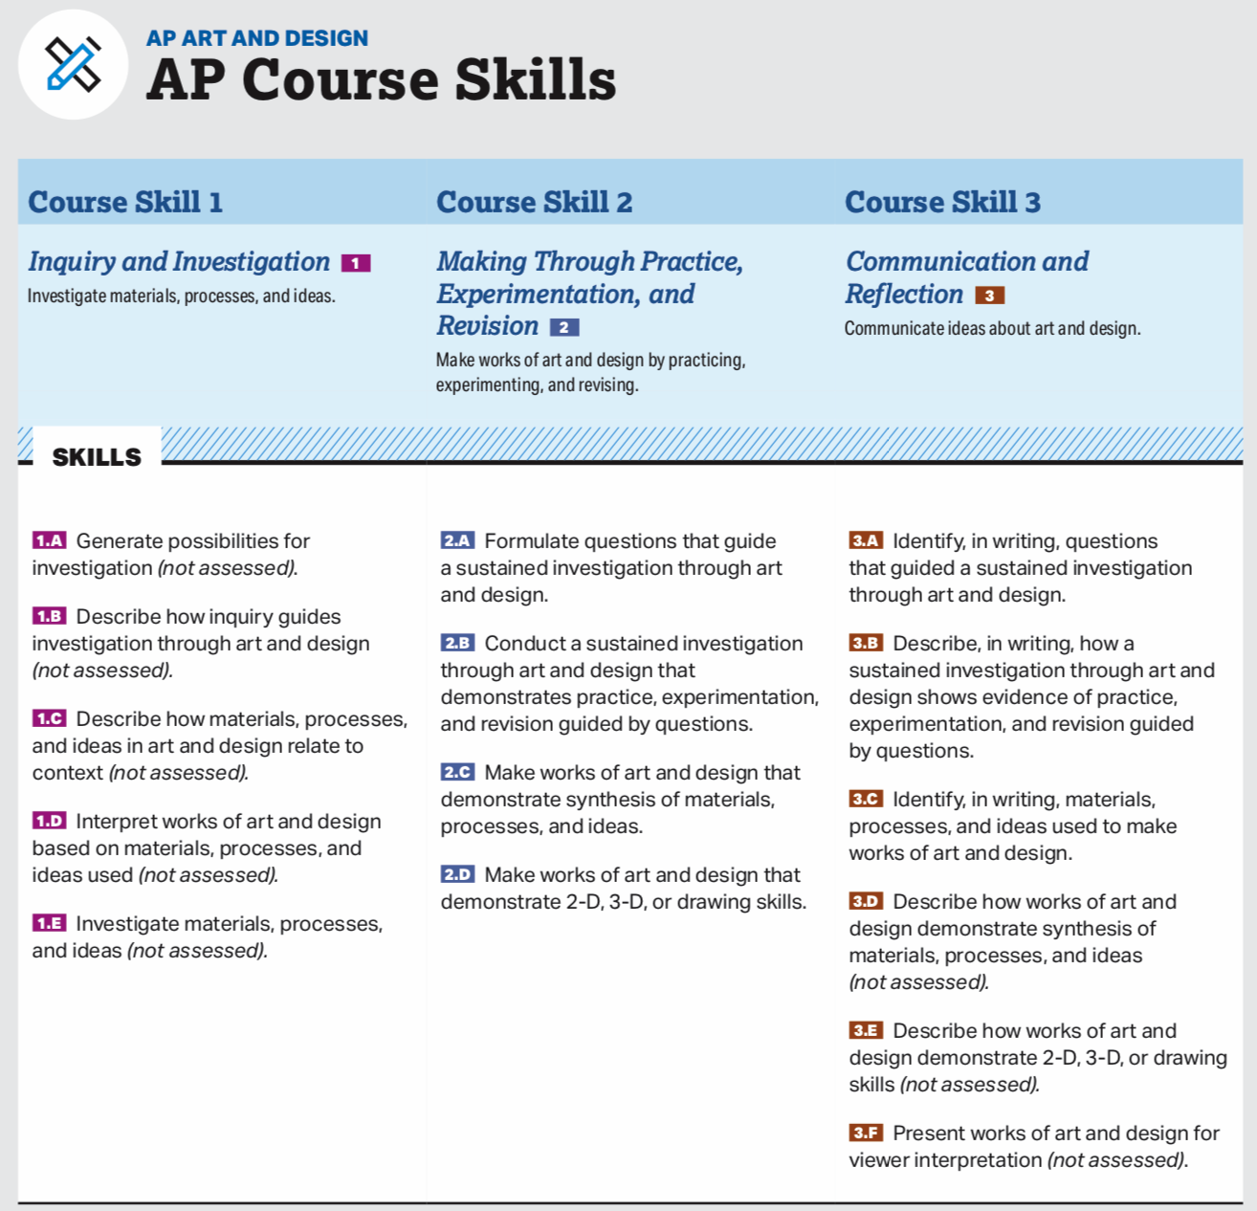
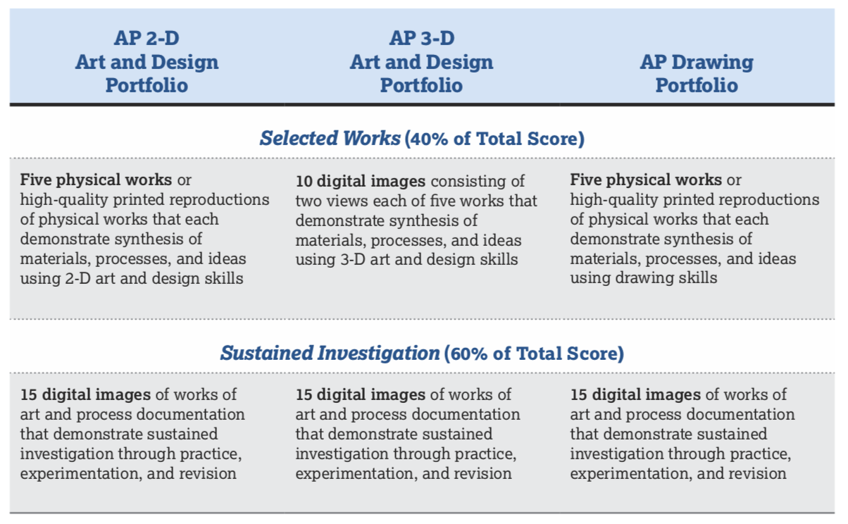

Portfolio Section #1: Selected Works
- Students should carefully select works that best demonstrate their skillful synthesis of materials, processes, and ideas. The submission can be a group of related works, unrelated works, or a combination of related and unrelated works. These works may also be submitted in the Sustained Investigation section, but they don’t have to be.
- Along with each work, students are required to submit written responses to prompts about the work. Responses are evaluated along with the images that students submit. The most successful responses in terms of assessment are those that are clearly related to the images of work submitted, that directly and completely address the prompts, and that provide further evidence of skillful synthesis of materials, processes, and ideas shown in the work. Responses are not evaluated for correct spelling, grammar, or punctuation.

Requirements & Prompts:
Submit five works that demonstrate:
- 2-D/3-D/drawing skills (depending on type of portfolio submitted)
- Synthesis of materials, processes, and ideas for each work, state the following in writing:
- Idea(s) visually evident (100 characters maximum, including spaces)
- Materials used (100 characters maximum, including spaces)
- Processes used (100 characters maximum, including spaces)

Portfolio Section #2: Sustained Investigation
- This section of the AP Art and Design Portfolio Exams offers students the opportunity to make and present works of art and design based on an in-depth investigation of materials, processes, and ideas done over time. Sustained investigation is guided by questions. It involves practice, experimentation, and revision using materials, processes, and ideas. The Sustained Investigation section is expected to demonstrate skillful synthesis of materials, processes, and ideas. Works from the Sustained Investigation section may also be submitted in the Selected Works section, but they don’t have to be.
- Along with each work, students are required to submit written responses to prompts about the work. Responses to these prompts are evaluated along with the images that students submit. The most successful responses in terms of assessment are those that are clearly related to the images of work submitted; that directly and completely address the prompts; and that provide evidence of inquiry-based sustained investigation through practice, experimentation, and revision. Responses are not evaluated for correct spelling, grammar, or punctuation.

Requirements & Prompts:
Submit 15 images that demonstrate
  - Sustained investigation of materials, processes, and ideas
  - Synthesis of materials, processes, and ideas
  - 2-D/3-D/drawing skills (depending on type of portfolio submitted)
State the following in writing:
    - Identify the questions that guided your sustained investigation
    - Describe how your sustained investigation shows evidence of practice, experimentation, and revision guided by your questions (1200 characters maximum, including spaces, for response to both prompts)

Drawing Portfolio Description:
- This portfolio is designated for work that focuses on the use of mark-making, line, surface, space, light and shade, and composition. Students should consider marks that can be used to make drawings, the arrangement of marks, the materials and processes used to make marks, and relationships of marks and ideas.
- Students can work with any materials, processes, and ideas. Drawing (analog and digital), painting, printmaking, and mixed media work are among the possibilities for submission. Still images from videos or film are accepted. Composite images may be submitted.
- Samples of student work for the AP Drawing portfolio can be found on AP Central at
apcentral.collegeboard .org/courses/ap-drawing.

2D Design Portfolio Description:
- This portfolio is designated for work that focuses on the use of two-dimensional (2-D) elements and principles of art and design, including point, line, shape, plane, layer, form, space, texture, color, value, opacity, transparency, time, unity, variety, rhythm, movement, proportion, scale, balance, emphasis, contrast, repetition, figure/ ground relationship, connection, juxtaposition, and hierarchy. Students should consider how materials, processes, and ideas can be used to make work that exists on a flat surface.
- Students can work with any materials, processes, and ideas. Graphic design, digital imaging, photography, collage, fabric design, weaving, fashion design, fashion illustration, painting, and printmaking are among the possibilities for submission. Still images from videos or film are accepted. Composite images may be submitted.
- Samples of student work for the AP 2-D Art and Design Portfolio Exam can be found on AP Central at apcentral.collegeboard.org/courses/ap-2-d-art-and -design.

Ethics, Artistic Integrity, and Plagiarism:
- Any work that makes use of (appropriates) photographs, published images, and/or the work of someone else must show substantial and significant development beyond duplication. This is demonstrated through manipulation of the materials, processes, and/or ideas of the source. The student’s individual vision should be clearly evident. It is unethical, constitutes plagiarism, and often violates copyright law simply to copy someone else’s work or imagery (even in another medium) and represent it as one’s own.
- Teachers and their students are strongly encouraged to become knowledgeable about copyright laws and to maintain reference citations for all resources used to develop student work. Teachers are expected to monitor students’ use of resources and to ensure that students understand and demonstrate integrity in making art and design. Students are encouraged to create works based on their own experiences, knowledge, and interests. Universities, colleges, and art schools have rigorous policies regarding plagiarism.
- Digital images of student work may be edited. However, the goals of image editing should be to present the clearest, most accurate representation of the student’s work and to ensure that images meet the requirements of the digital submission web application. When submitting their portfolios, students must attest: “I hereby affirm that all works in this portfolio were done by me and that these images accurately represent my actual work.”
- The College Board reserves the right to decline to score an AP Art and Design Portfolio Exam or cancel an AP Art and Design Portfolio Exam when misconduct occurs, such as copying another artist’s work.
Documenting Artwork:
- It is essential for students to understand the significance of image quality when they create and select digital images to submit for their AP Art and Design Portfolio Exam. Images that are unclear, out of focus, lacking in contrast and detail, distorted, too light or dark, incomplete, ambiguous, and/or include distracting backgrounds do not support success with the AP Art and Design Portfolio Exams.
- When photographing work and documenting process for their portfolio, students should capture the highest- quality images possible. They can use software of their choice to edit images, saving both high-resolution image files and image files that meet AP Art and Design digital submission specifications.
- Image specifications for the AP Art and Design digital submission web application can be found at apstudent.org/art-and-design-digital-submission.

